

Hands on Training on Embedded System Design

Trainers Manual

Session-11

www.interlogicx.com
LCD DISPLAY

It is very important to keep a track of the working of almost all the automated and semi-automated devices, be it a washing machine, an autonomous robot or anything else. This is achieved by displaying their status on a small display module. LCD (Liquid Crystal Display) screen is such a display module and a 16x2 LCD module is very commonly used. These modules are replacing seven segments and other multi segment LEDs for these purposes.

LCD (Liquid Crystal Display) screen is an electronic display module and find a wide range of applications. A 16x2 LCD display is very basic module and is very commonly used in various devices and circuits. These modules are preferred over seven segments and other multi segment LEDs. The reasons being: LCDs are economical; easily programmable; have no limitation of displaying special & even custom characters (unlike in seven segments), animations and so on.

A 16x2 LCD means it can display 16 characters per line and there are 2 such lines. In this LCD each character is displayed in 5x7 pixel matrix. This LCD has two registers, namely, Command and Data. The command register stores the command instructions given to the LCD. A command is an instruction given to LCD to do a predefined task like initializing it, clearing its screen, setting the cursor position, controlling display etc. The data register stores the data to be displayed on the LCD. The data is the ASCII value of the character to be displayed on the LCD.

Pin Diagram

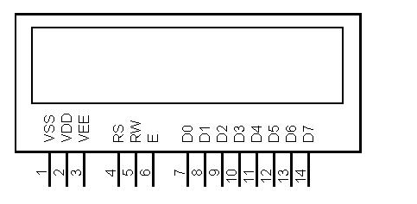

Pin Description:

Pin No | Function | Name
1 | Ground (0V) | Ground
2 | Supply voltage; 5V (4.7V – 5.3V) | Vcc
3 | Contrast adjustment; through a variable resistor | V_{EE}
4 | Selects command register when low; and data register when high | Register Select
5 | Low to write to the register; High to read from the register | Read/write
6 | Sends data to data pins when a high to low pulse is given | Enable
7 | 8-bit data pins | DB0
8 | 8-bit data pins | DB1
9 | 8-bit data pins | DB2
10 | 8-bit data pins | DB3
11 | 8-bit data pins | DB4
12 | 8-bit data pins | DB5
13 | 8-bit data pins | DB6
14 | 8-bit data pins | DB7
15 | Backlight V_{CC} (5V) | Led+
16 | Backlight Ground (0V) | Led-

The LCD display module requires 3 control lines as well as either 4 or 8 I/O lines for the data bus. The user may select whether the LCD is to operate with a 4-bit data bus or an 8-bit data bus. If a 4-bit data bus is used the LCD will require a total of 7 data lines (3 control lines plus the 4 lines for the data bus). If an 8-bit data bus is used the LCD will require a total of 11 data lines (3 control lines plus the 8 lines for the data bus).
The three control lines are referred to as EN, RS, and RW.
The EN line is called "Enable." This control line is used to tell the LCD that you are sending it data. To send data to the LCD, your program should make sure this line is low (0) and then set the other two control lines and/or put data on the data bus. When the other lines are completely ready, bring EN high (1) and wait for the minimum amount of time required by the LCD datasheet (this varies from LCD to LCD), and end by bringing it low (0) again.
The RS line is the "Register Select" line. When RS is low (0), the data is to be treated as a command or special instruction (such as clear screen, position cursor, etc.). When RS is high (1), the data being sent is text data which should be displayed on the screen. For example, to display the letter "T" on the screen you would set RS high.
The RW line is the "Read/Write" control line. When RW is low (0), the information on the data bus is being written to the LCD. When RW is high (1), the program is effectively querying (or reading) the LCD. Only one instruction ("Get LCD status") is a read command. All others are write commands--so RW will almost always be low.
Finally, the data bus consists of 4 or 8 lines (depending on the mode of operation selected by the user). In the case of an 8-bit data bus, the lines are referred to as DB0, DB1, DB2, DB3, DB4, DB5, DB6, and DB7.

LCD COMMANDS

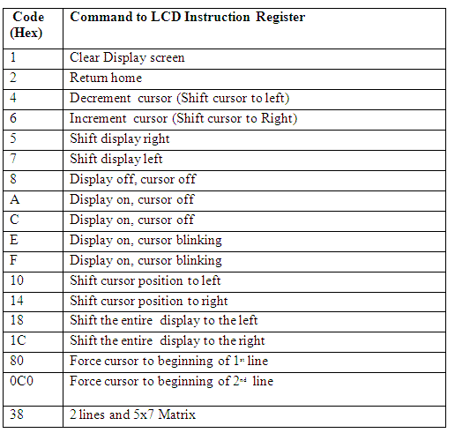

CIRCUIT DIAGRAM

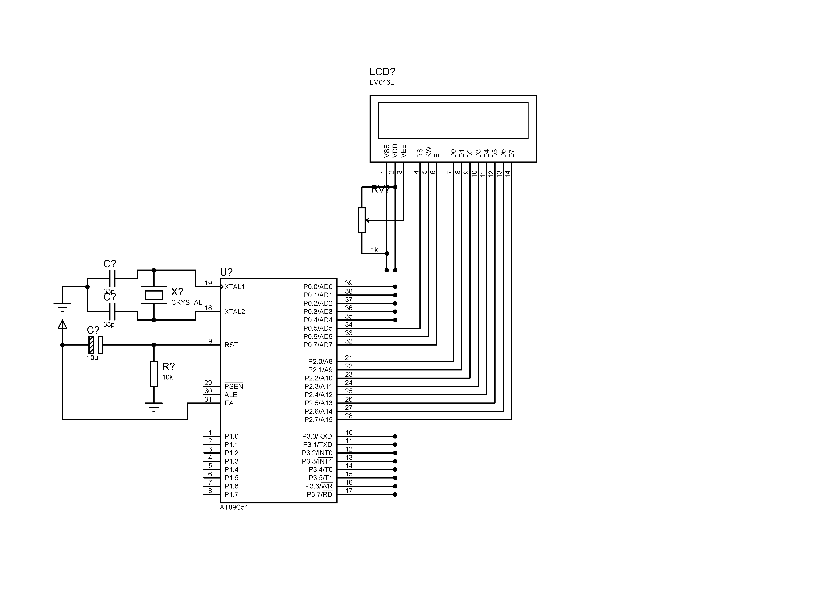
Programming the LCD

- To send data on the LCD, data is first written to the data pins with R/W = 0 (to specify the write operation) and RS = 1 (to select the data register). A high to low pulse is given at EN pin when data is sent. Each write operation is performed on the positive edge of the Enable signal.
- To send a command on the LCD, a particular command is first specified to the data pins with R/W = 0 (to specify the write operation) and RS = 0 (to select the command register). A high to low pulse is given at EN pin when data is sent.

Displaying string on LCD
The LCD is interfaced with microcontroller (MCS51). This microcontroller has 40 pins with four 8-bit ports (P₀, P₁, P₂, and P₃). Here P₂ is used as output port which is connected to data pins of the LCD. The control pins (pin 4-6) are controlled by pins 7-5 of P₀ port. Pin 3 is connected to a preset of 1K to adjust the contrast on LCD screen. This program uses the above concepts of interfacing the LCD with controller by displaying the string INTERLOGICX.

Program for LCD display to string INTERLOGICX
#include <REG51.H>
#define DELAY for(i=0;i<=1500;i++)
#define LCDDATA P2

void initialize();
void comwrt(unsigned char);
void datawrt(unsigned char);

sbit RS = P0^7;
sbit RW = P0^6;
sbit EN = P0^5;

void main()
{
unsigned char name[]="Interlogicx",j;

initialize();
while(1)
{
for(j=0;j<11;j++)
{
datawrt(name[j]); /* send_string("interlogicx");*/
}
}
}

void initialize()
{
unsigned int i,j;
int com[]={0x38,0x0E,0x01,0x06,0x80};
for(j=0;j<=4;j++)
{
comwrt(com[j]);
DELAY;
}
}

void comwrt(unsigned char x)
{
unsigned int i;
LCDDATA=x;
RS = 0;
RW = 0;
EN = 1;
DELAY;
EN = 0;
}

void datawrt(unsigned char y)
{
unsigned int i;
LCDDATA=y;
RS = 1;
RW = 0;
EN = 1;
DELAY;
EN = 0;
}

